UNICEF Toolkit on Diversion and Alternatives to Detention 2009

UNICEF and UNODC 15 Juvenile Justice Indicators

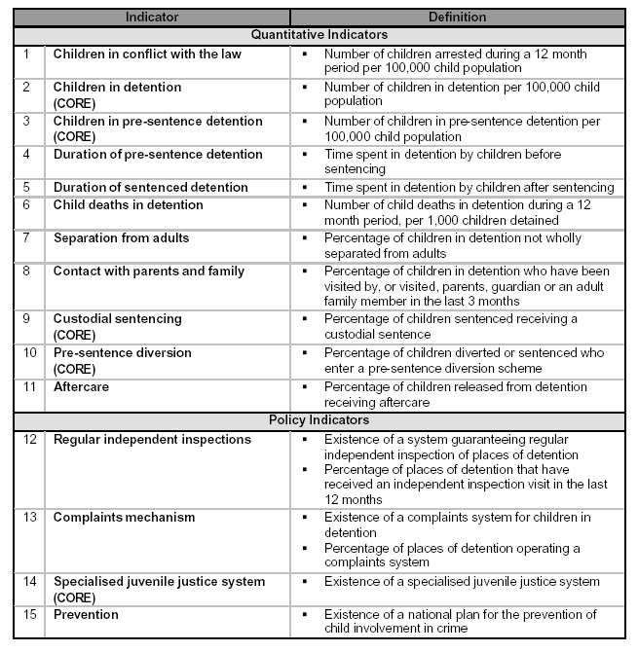

Refer also to the full Manual for the Measurement of Juvenile Justice Indicators, UNICEF and UNODC, April 2006, which is available to download in the ‘Resources’ section of this toolkit.

