UNICEF Toolkit on Diversion and Alternatives to Detention 2009
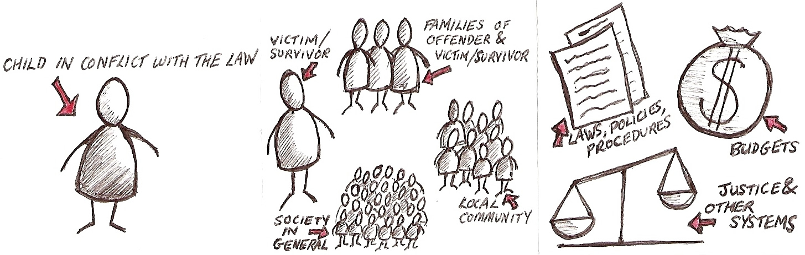
Planning & implementation:participatory development of indicators (‘indicator diagram)
Process indicators:
What activities will lead us to the results we want to achieve?
Impact indicators:
What results should we aim for that are indicative of positive impact on beneficiaries? (Make sure there is logic / sequence between levels)

Beneficiaries & other stakeholders
Individuals & organisations
Child
Professionals
Government & administration
Society
Participatory planning & implementation

IMPACT
OUTCOME 1 |  |  |  | OUTCOME 2 |  |  |  | OUTCOME 3
OUTPUT 1.1 |  | OUTPUT 1.2 |  | OUTPUT 2.1 |  | OUTPUT 2.2 |  | OUTPUT 3.1 |  | OUTPUT 3.2
Activity 1.1.1 | Activity 1.1.2 | Activity 1.2.1 | Activity 1.2.2 | Activity 2.1.1 | Activity 2.1.2 | Activity 2.2.1 | Activity 2.2.2 | Activity 3.1.1 | Activity 3.1.2 | Activity 3.2.1 | Activity 3.2.2

